20.8: a) From
b) 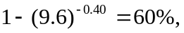 an increase of 2%. If more figures are kept for the efficiencies, the difference is 1.4%.

